**Ideation Phase**

**Define the Problem Statements**

|  |  |
| --- | --- |
| Date | 27 – June-2025 |
| Team ID | LTVIP2025TMID30752 |
| Project Name | Sustainable Smart City Assistant Using IBM Granite LLM |
| Maximum Marks | 2 Marks |

**Customer Problem Statement Template:**

**Customers (citizens and city administrators)** need a smarter, more accessible way to understand urban policies, track sustainability KPIs, and contribute to city development—because current systems are complex, fragmented, and lack real-time interaction or actionable insights.

Today, citizens are often unaware of policy changes or environmental trends due to overwhelming information formats and inaccessible reports. Similarly, city planners struggle to interpret historical data, identify anomalies, or forecast key resource usage quickly and accurately. Feedback systems, when available, are outdated or ignored, leading to mistrust and poor engagement.

Without a centralized, AI-powered assistant, users feel disconnected from smart city initiatives, miss opportunities for sustainable practices, and face delays in identifying urgent city infrastructure issues.

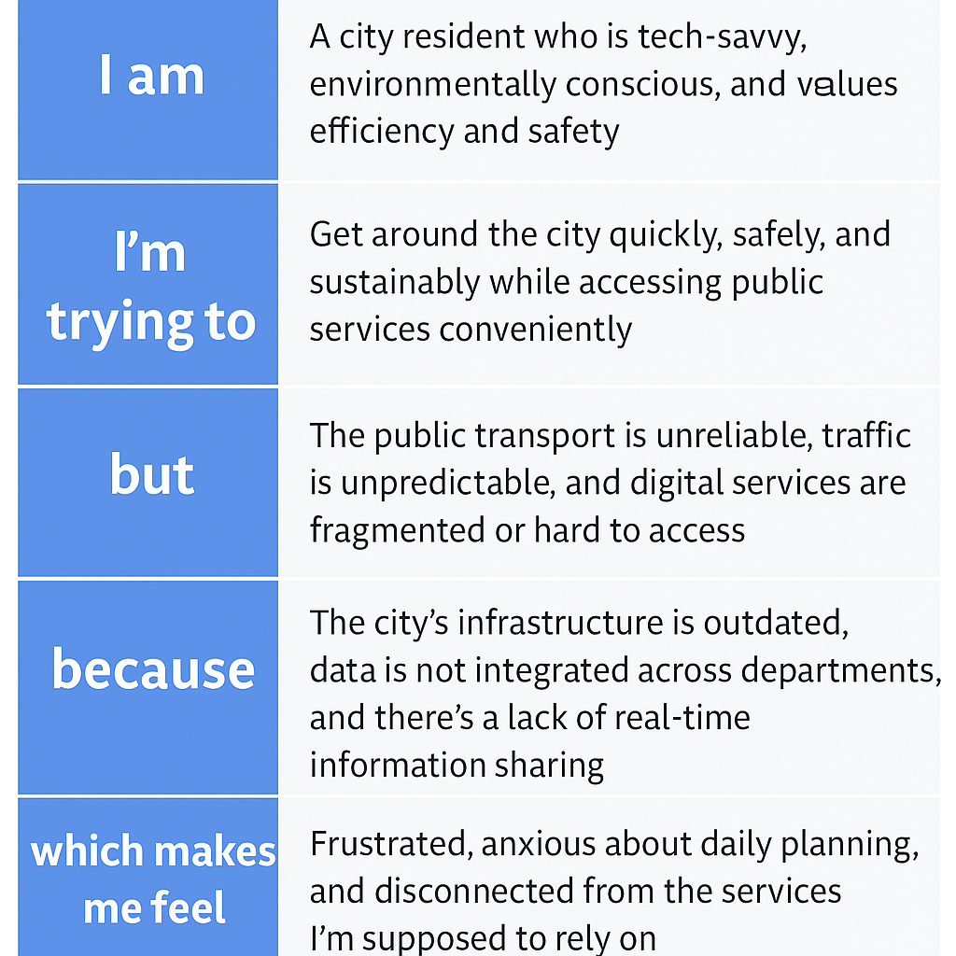

**Example:**

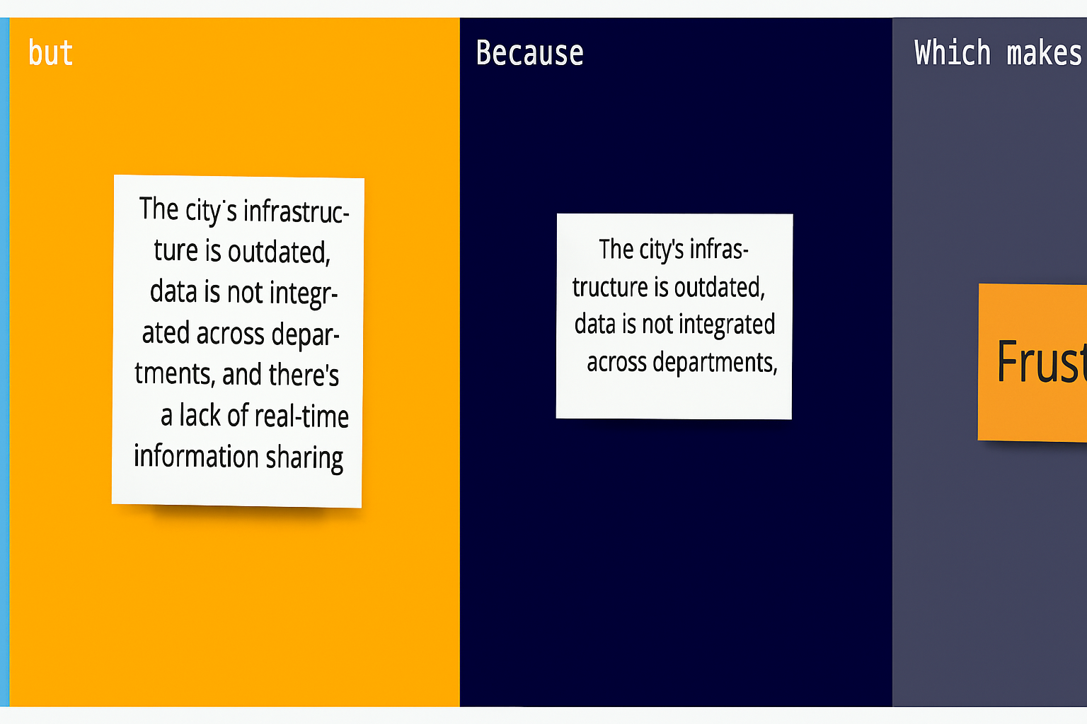

|  |  |  |  |  |  |
| --- | --- | --- | --- | --- | --- |
| **Problem Statement (PS)** | **I am (Customer)** | **I’m trying to** | **But** | **Because** | **Which makes me feel** |
| PS-1 | |  | | --- | |  |  |  | | --- | | A concerned citizen who wants to  contribute to sustainability and  civic improvement | | Understand city policies and contribute feedback to improve services | The documents are too technical, and feedback portals are confusing | The city doesn’t offer citizen-friendly summaries or easy reporting tools | Frustrated, excluded, and unsure if my opinion matters |
| PS-2 | |  | | --- | |  |  |  | | --- | | A city administrator responsible for  urban planning and resource  monitoring | | |  | | --- | | responsible for urban planning and resource monitoring |  |  | | --- | | Analyze environmental KPIs and predict future needs (e.g., water, electricity, pollution) | | Manual analysis is time-consuming and lacks AI insight | There’s no smart system to forecast trends or detect anomalies in uploaded CSV files | Overwhelmed, stressed, and worried about making uninformed decisions |